**Experiment No. 2**

**Aim:** Create “Hello World” application to “Hello World” in the middle of the screen in the red colour with white background.

**Program:**

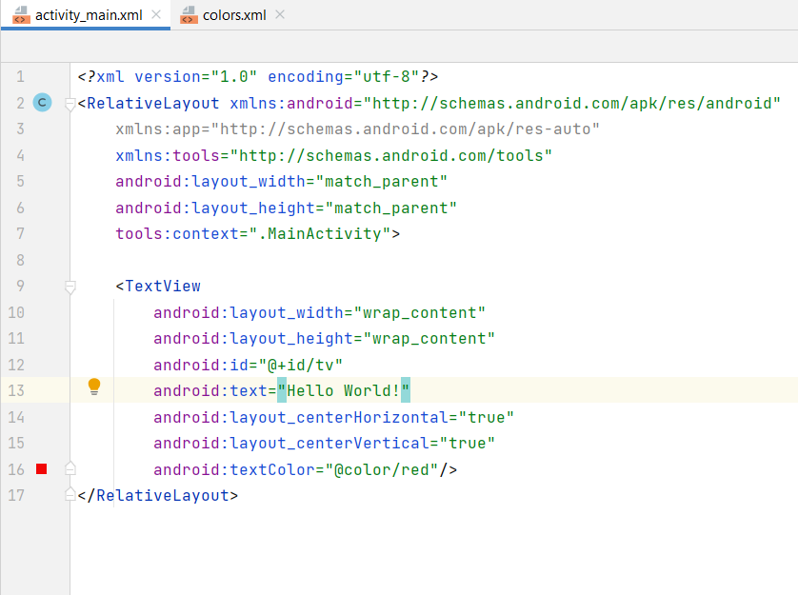

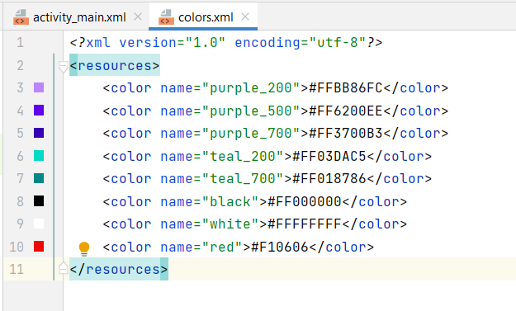

**Output:**

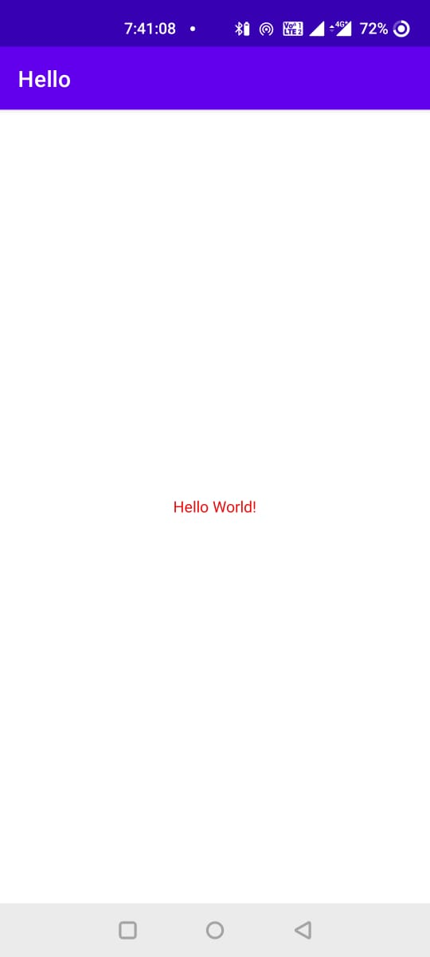

**Conclusion:**

Hence, by completing this experiment I came to know how to Create “Hello World” application to “Hello World” in the middle of the screen in the red colour with white background.

|  |  |  |  |
| --- | --- | --- | --- |
| **Writeup & Oral**  **(4)** | **Practical Performance**  **(4)** | **Attendance**  **(2)** | **Total**  **(10)** |
|  |  |  |  |